React – Labs

**Lab1 – simple component**

Create a component for a Math exam question. Add 3 textboxes for arguments and result

Add a code to generate 2 random numbers and operand (+,-,*,/) and a button to check the result . Change the background of result textbox based on the result (correct – green, no correct – red)

**Lab2 – multiple components**

Based on the previous lab create a full Math test app

Header – add textbox to get the number of question requested and a button to generate the test

Body – add a table with multiple components as a question

Footer – add a button to check the exam and label to display the grade

**Lab3 – 2 way data binding**

Create a grid control:

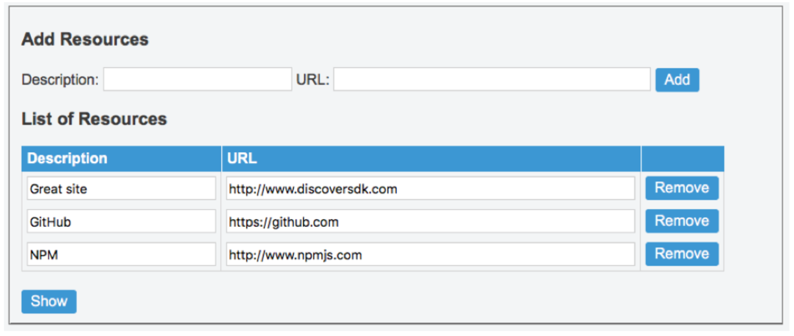

implements all the events to support add , remove and update a resource. By clicking the show button display a json object with all the data

**Lab4 – Full CRUD App**

Create a Library management system, add welcome page, books , customers and loans

Add routing and use HTTP request with json-server module

Add bootstrap navbar as the main menu:



On the home page create a jumbotron with a welcome message:

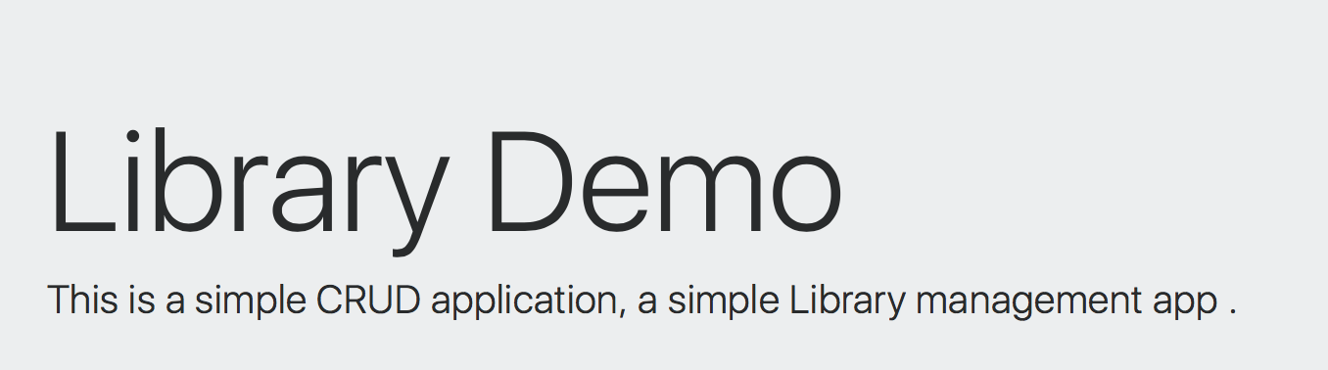

Books page:

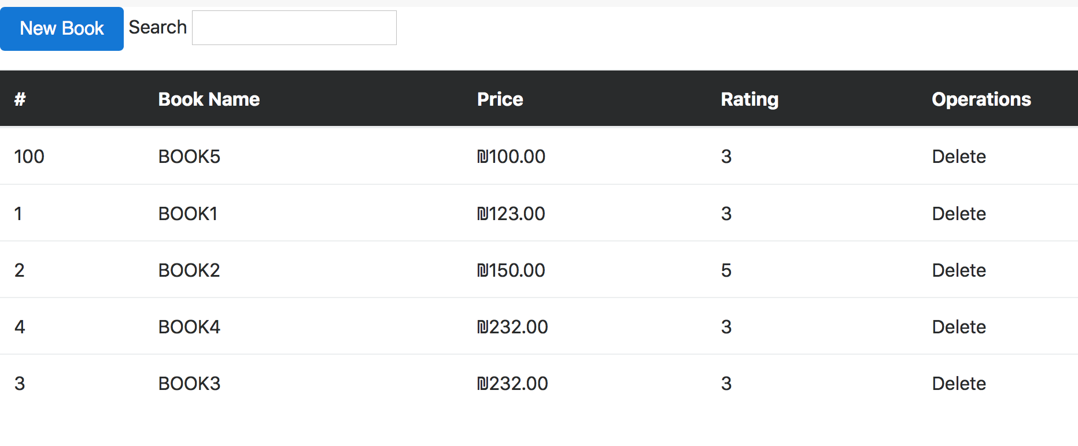

implements the search filter, sort the table by clicking the header

implement the delete operation

new book open a dialog

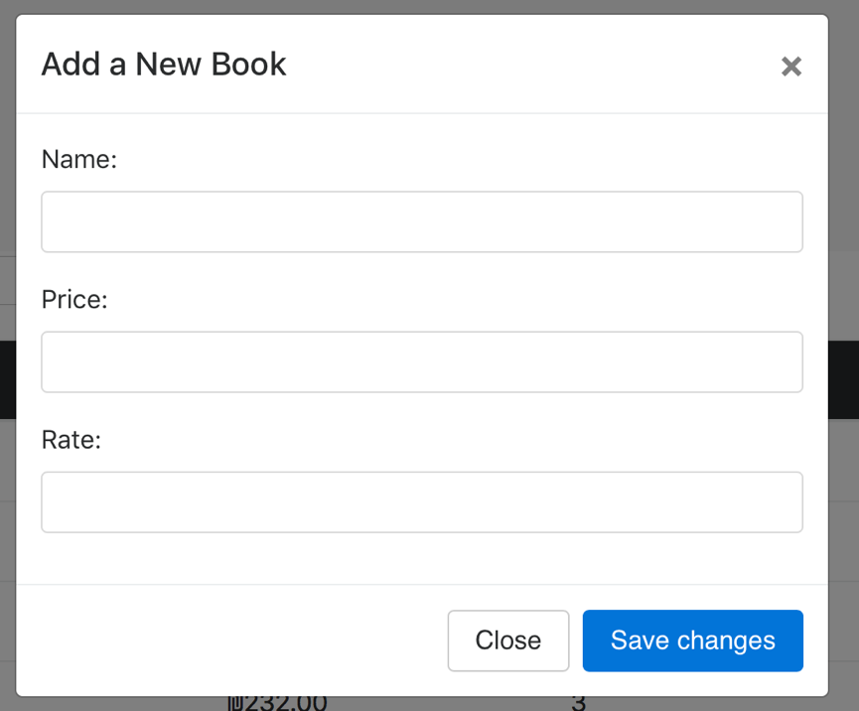

Implement the customers page the same way

Loans page

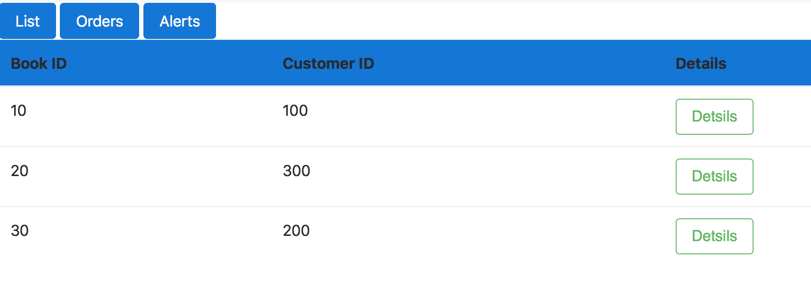

Add child route with a sub menu for loans list, orders and alerts

Details – open a page with all the loan details (book details, customer details, date etc)